|  |
| --- |
| **Behaviour Individual Pupil Risk Assessment (BIPRA)** |

|  |  |  |  |  |  |  |  |  |
| --- | --- | --- | --- | --- | --- | --- | --- | --- |
| **School Name:** |  | | | | | **Date:** | | Click or tap to enter a date. |
| **Name of Head/Centre Manager:** | | |  | | | | | |
| **Pupil Name:** | |  | **D.O.B:** |  | **School Year:** | | Choose an item. | |

|  |  |  |  |  |  |  |  |  |  |  |
| --- | --- | --- | --- | --- | --- | --- | --- | --- | --- | --- |
| **Name of person completing this form:** |  | | | | | | | | | |
| **Name of person(s) contributing to this form:** |  | | | | | | | | | |
| **Revision Dates:** | **1** |  | **2** |  | **3** |  | **4** |  | **5** |  |

|  |  |  |  |
| --- | --- | --- | --- |
| **Additional Information:** | | | |
| For additional guidance, please see BIPRA Support Document. This will guide you through completion of this form.  Whether the BIPRA is active or redundant the document should be retained for - Pupil DOB +21 years. If the BIPRA refers to a child who requires restrictive physical intervention then this document, and any revised versions, should be retained for pupil DOB +75 years. | | | |
|  | | | |
| Likelihood | Unlikely (1) | Possible (2) | Likely (3) |
| Consequence |
| Slightly Harmful (1) | Trivial (1) | Acceptable (2) | Moderate (3) |
| Harmful (2) | Acceptable (2) | Moderate (4) | Substantial (6) |
| Extremely Harmful (3) | Moderate (3) | Substantial (6) | Unacceptable (9) |
|  |  |  |  |
| Trivial and Acceptable  (1-2)  No action is required for this risk rating. All documentation should be kept for future reference in case of a civil claim, FOI or similar. | Moderate  (3-5)  If practicable to do so, then additional controls should be put into place to further reduce the risk. | Substantial  (6-8)  Further action should be taken immediately to reduce the risk. Setting may wish to engage the services of external professionals. | Unacceptable  (9)  Action must be taken immediately to reduce the risk. External professional advice should be sought to mitigate and alleviate the prescribed risks of harm. |

|  |
| --- |
| **Key Information: Pupil overview (see supporting doc)** |
|  |

|  |  |  |  |
| --- | --- | --- | --- |
| **Parent/Carer View/s:** | | | |
| **This BIPRA has been read and understood by (Name):** | |  | |
| **Relationship to pupil:** |  | **Date:** | Click or tap to enter a date. |
| **Parent/Carer Views:** | | | |
|  | | | |

|  |  |  |  |
| --- | --- | --- | --- |
| Hazard 1: | | | |
| WHAT is the hazard? And give a brief example of previous behaviour. (The situation may be the source of the potential danger.) | | | |
|  | | | |
| WHO might be harmed by the above-mentioned hazard? It could be more than one person. | | | |
|  | | | |
| HOW may the identified individual or persons be injured by the hazard | | | |
|  | | | |
| The first risk rating assumes that you are doing NOTHING to prevent the harm indicated above. | | | |
| Risk Rating BEFORE controls- | | The potential consequence is | Choose an item. |
| The likelihood of this is | Choose an item. |
| Risk Rating before controls is | Choose an item. |
| Control Measures: | | | |
| 1 |  | | |
| 2 |  | | |
| 3 |  | | |
| 4 |  | | |
| 5 |  | | |
| 6 |  | | |
| 7 |  | | |
| 8 |  | | |
| 9 |  | | |
| This Risk Assessment has been shared, read, and understood by the following staff (initials) | | | |
|  | | | |
| Risk Rating AFTER controls- | | The potential consequence is | Choose an item. |
| The likelihood of this is | Choose an item. |
| Risk Rating After controls is | Choose an item. |

|  |  |  |  |
| --- | --- | --- | --- |
| Hazard 2: | | | |
| WHAT is the hazard? And give a brief example of previous behaviour. (The situation may be the source of the potential danger.) | | | |
|  | | | |
| WHO might be harmed by the above-mentioned hazard? It could be more than one person. | | | |
|  | | | |
| HOW may the identified individual or persons be injured by the hazard | | | |
|  | | | |
| The first risk rating assumes that you are doing NOTHING to prevent the harm indicated above. | | | |
| Risk Rating BEFORE controls- | | The potential consequence is | Choose an item. |
| The likelihood of this is | Choose an item. |
| Risk Rating before controls is | Choose an item. |
| Control Measures: | | | |
| 1 |  | | |
| 2 |  | | |
| 3 |  | | |
| 4 |  | | |
| 5 |  | | |
| 6 |  | | |
| 7 |  | | |
| 8 |  | | |
| 9 |  | | |
| This Risk Assessment has been shared, read, and understood by the following staff (initials) | | | |
|  | | | |
| Risk Rating AFTER controls- | | The potential consequence is | Choose an item. |
| The likelihood of this is | Choose an item. |
| Risk Rating After controls is | Choose an item. |

|  |  |  |  |
| --- | --- | --- | --- |
| Hazard 3: | | | |
| WHAT is the hazard? And give a brief example of previous behaviour. (The situation may be the source of the potential danger.) | | | |
|  | | | |
| WHO might be harmed by the above-mentioned hazard? It could be more than one person. | | | |
|  | | | |
| HOW may the identified individual or persons be injured by the hazard | | | |
|  | | | |
| The first risk rating assumes that you are doing NOTHING to prevent the harm indicated above. | | | |
| Risk Rating BEFORE controls- | | The potential consequence is | Choose an item. |
| The likelihood of this is | Choose an item. |
| Risk Rating before controls is | Choose an item. |
| Control Measures: | | | |
| 1 |  | | |
| 2 |  | | |
| 3 |  | | |
| 4 |  | | |
| 5 |  | | |
| 6 |  | | |
| 7 |  | | |
| 8 |  | | |
| 9 |  | | |
| This Risk Assessment has been shared, read, and understood by the following staff (initials) | | | |
|  | | | |
| Risk Rating AFTER controls- | | The potential consequence is | Harmful (2) |
| The likelihood of this is | Likely (3) |
| Risk Rating After controls is | Substantial (6) |

|  |  |  |  |
| --- | --- | --- | --- |
| Hazard 4: | | | |
| WHAT is the hazard? And give a brief example of previous behaviour. (The situation may be the source of the potential danger.) | | | |
|  | | | |
| WHO might be harmed by the above-mentioned hazard? It could be more than one person. | | | |
|  | | | |
| HOW may the identified individual or persons be injured by the hazard | | | |
|  | | | |
| The first risk rating assumes that you are doing NOTHING to prevent the harm indicated above. | | | |
| Risk Rating BEFORE controls- | | The potential consequence is | Choose an item. |
| The likelihood of this is | Choose an item. |
| Risk Rating before controls is | Choose an item. |
| Control Measures: | | | |
| 1 |  | | |
| 2 |  | | |
| 3 |  | | |
| 4 |  | | |
| 5 |  | | |
| 6 |  | | |
| 7 |  | | |
| 8 |  | | |
| 9 |  | | |
| This Risk Assessment has been shared, read, and understood by the following staff (initials) | | | |
|  | | | |
| Risk Rating AFTER controls- | | The potential consequence is | Choose an item. |
| The likelihood of this is | Choose an item. |
| Risk Rating After controls is | Choose an item. |

|  |
| --- |
| **Positive Behaviour Support Plan (PBSP)** |

|  |  |  |  |  |  |  |  |  |
| --- | --- | --- | --- | --- | --- | --- | --- | --- |
| **Please note that should the Pupil have a BIPRA in place, then a PBSP must be Completed:** (Although a PBSP could be used as a stand-alone document to support pupils in learning with non-restrictive physical interventions being listed.) | | | | | | | | |
| **School Name:** |  | | | | | **Date:** | Click or tap to enter a date. | |
| **Name of Head/Centre Manager:** | | |  | | | | | |
| **Pupil Name:** | |  | **D.O.B:** |  | **School Year:** | | | Choose an item. |

|  |  |
| --- | --- |
| **Name of person completing this form:** |  |
| **Name of person(s) contributing to this form:** |  |

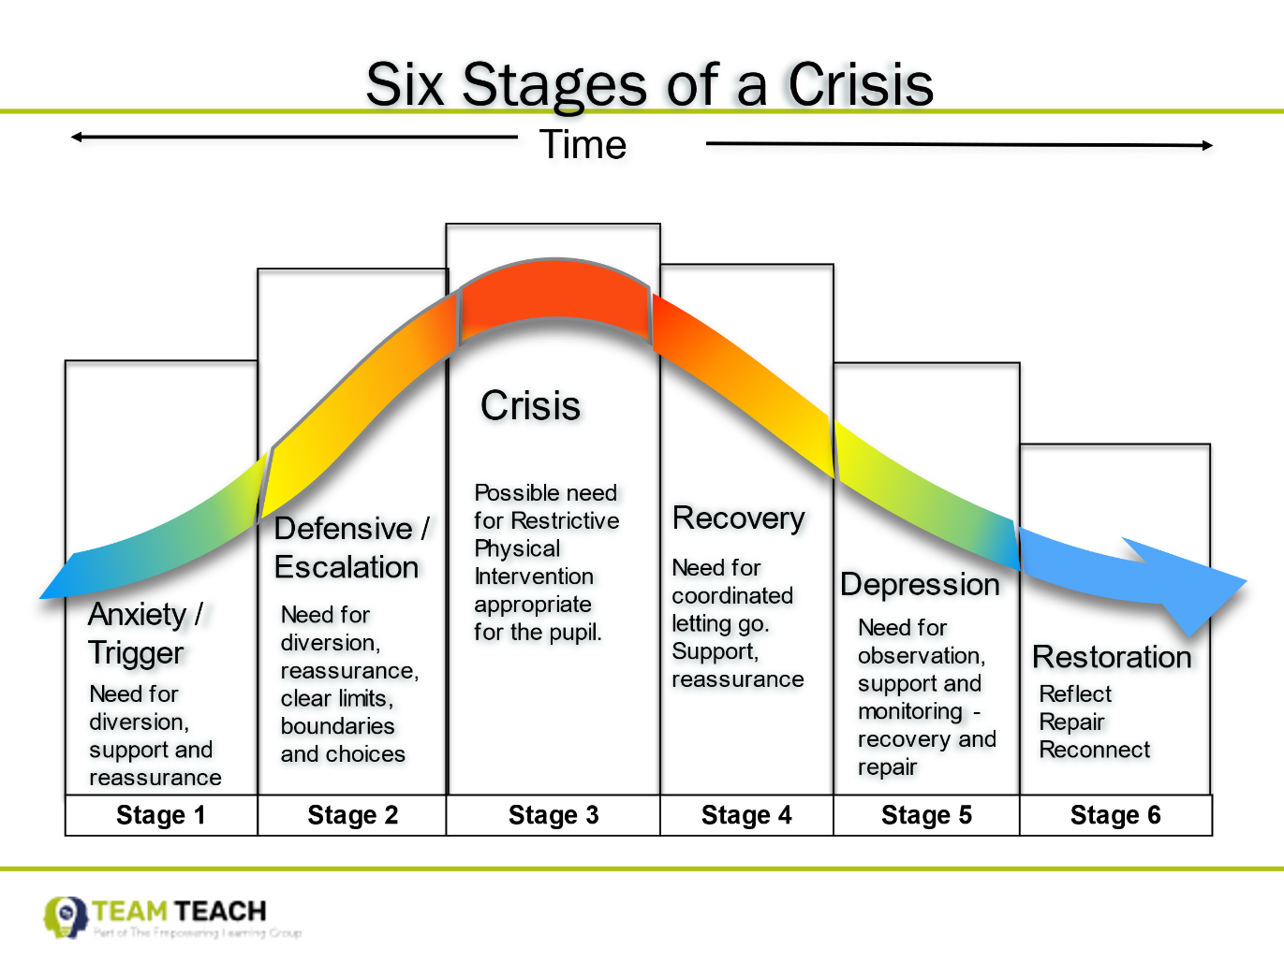

**Primary**

**Secondary**

**Tertiary**

|  |
| --- |
| **Medical Conditions: (Any medical or physical condition that could impact on the use of physical intervention.)** |
|  |

|  |  |
| --- | --- |
| **Has a BIPRA been completed?** | Choose an item. |

|  |  |
| --- | --- |
| **Primary Stage – Behaviours:**  Lead up-Triggers, Worries, Escalators: (TWE)  Describe common situations which staff have previously identified a need for further support and when these behaviours are likely to occur. | |
|  | |
| **Early Indicator Behaviour:**  Early Indicators - How does pupil present? (Signs that identify the start of dysregulation and possible need for support). | |
|  | |
| **DOs** – suggestive strategies for de-escalation. This can include the pupil’s interests, activities and resources that are useful. | **DON’Ts** – Actions which may escalate the pupil’s behaviour further |
|  |  |

|  |  |
| --- | --- |
| **Secondary Stage - Behaviours:**  Behaviours that indicate the pupil is escalating toward crisis level and strategies to keep the pupil and others safe. | |
| **Behaviour:** | |
|  | |
| **DOs** – Suggestive strategies for de-escalation. | **DON’Ts** – Actions which may escalate the pupil’s behaviour further |
|  |  |

|  |  |
| --- | --- |
| **Behaviour:** | |
|  | |
| **DOs** – suggestive strategies for de-escalation. | **DON’Ts** – Actions which may escalate the pupil’s behaviour further |
|  |  |

|  |  |
| --- | --- |
| **Behaviour:** | |
|  | |
| **DOs** – suggestive strategies for de-escalation. | **DON’Ts** – Actions which may escalate the pupil’s behaviour further |
|  |  |

|  |
| --- |
| **Tertiary Stage - Physical Intervention Strategies – Personal Safety**Describe any strategies which have worked in the past or should be avoided unless appropriate risk is present. All restrictive physical interventions should where possible be performed by staff who have been trained in each particular technique listed. |

|  |  |
| --- | --- |
| **Arm responses:** |  |
| Side-step in | Choose an item. |
| Cross step in | Choose an item. |
| Drop elbow | Choose an item. |
| Pump | Choose an item. |
| Conductor | Choose an item. |
| Clock | Choose an item. |
| Crossover | Choose an item. |
| **Neck disengagement:** | |
| Steering wheel | Choose an item. |
| Fix & stabilise | Choose an item. |
| Windmill | Choose an item. |
| Snake | Choose an item. |
| Elbow swing | Choose an item. |
| Neck Brace | Choose an item. |
| Bar & brace-behind | Choose an item. |
| Elbow guide out of headlock | Choose an item. |
| Spin out of strangle | Choose an item. |
| **Prompts Guides & Separations:** | |
| Prompt touch | Choose an item. |
| Caring C guide | Choose an item. |
| Steering away | Choose an item. |
| Arm waltz | Choose an item. |
| Turn gather guide | Choose an item. |
| Half shield | Choose an item. |
| **Clothing responses:** | |
| Closed fist hold | Choose an item. |
| Tube grip | Choose an item. |
| Close to neck | Choose an item. |
| From behind | Choose an item. |
| **Hair responses:** |  |
| One handed grab | Choose an item. |
| Two handed grab | Choose an item. |
| Knuckle squeeze | Choose an item. |
| **Bite responses:** |  |
| Eye bulge | Choose an item. |
| Jaw manual manipulation | Choose an item. |

|  |  |
| --- | --- |
| **One Person Holds:** | |
| Prompt touch | Choose an item. |
| Caring C guide | Choose an item. |
| Single person double elbow | Choose an item. |
| **Small Child Supports:** |  |
| Caring C guide | Choose an item. |
| Caring C kneeling | Choose an item. |
| Kneeling double elbow | Choose an item. |
| Two-person friendly escort | Choose an item. |
| Beanbags to hold single person | Choose an item. |
| Bean bags to hold two person friendly | Choose an item. |
| Change of face in beanbag | Choose an item. |
| Help alongside beanbag | Choose an item. |
| Response to dead weight | Choose an item. |
| **Two Person Holds:** | |
| Friendly escort | Choose an item. |
| Single elbow | Choose an item. |
| Figure of four | Choose an item. |
| Double elbow | Choose an item. |
| Response to dead weight | Choose an item. |
| Response to spitting | Choose an item. |
| Sitting in hold / beanbag option | Choose an item. |
| Moving to seated position | Choose an item. |
| Responses to kicking | Choose an item. |
| Change of face in seated | Choose an item. |

|  |
| --- |
| **Restoration Stage:**  It is best practice after an incident that a pupil receives support through restorative practice. This should take place after the incident when the pupil is regulated and able to engage. |

|  |
| --- |
| **How should restorative practice be done?**  Describe any strategies that have worked in the past. For example, how long should the child be left to calm before this happens, where should this take place, who should do the debrief? Etc… |
|  |
| **Pupil voice – Where and how will this be recorded?** |
|  |
| **Recording & Reporting – How will any RPI be recorded and where?** |
|  |
| **Parent notified? How?** |
|  |
| **SLT made aware? How?** |
|  |

|  |  |  |  |  |  |  |
| --- | --- | --- | --- | --- | --- | --- |
| **Signatures:** | | | | | | |
| School: |  | Name: |  | Date: | Click or tap to enter a date. |
| Parent/Carer |  | Name: |  | Date: | Click or tap to enter a date. |